Table of Contents
Section | Title
Introduction | DataQual
1 | Initial Setup
2 | Navigating the Streamlit Application

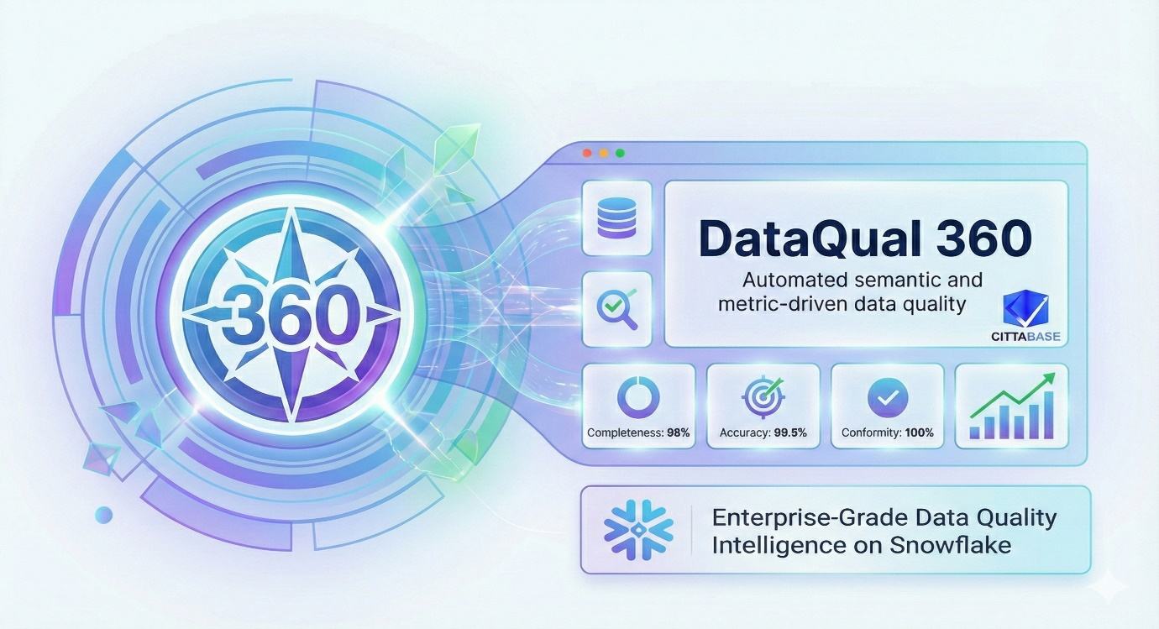

DataQual
AI-powered data quality, driven by semantic context
DataQual is a Snowflake-native, Streamlit-based application designed to simplify and accelerate data quality management across your data landscape. If you have data in Snowflake and want to quickly assess its reliability, enforce quality standards, and monitor data health over time, DataQual is your go-to solution. By leveraging the power of semantic views, and AI-powered intelligence, DataQual provides a 360 degree view on data quality and enables teams to generate meaningful metrics, define context-aware rules, uncover actionable insights ensuring trusted, decision-ready data at scale.

✅ Run Metrics and Rules: Select a database, schema, semantic view, and table to generate data quality metrics and context-aware validation rules. This intuitive interface leverages table data using Snowflake’s Semantic views to automatically profile data, define intelligent rules, and run validations, enabling teams to quickly assess data quality and enforce standards with confidence. Additionally, we have a chat assistant to ask questions and get insights about the data.
✅ Data Quality and Recommendations: Select a database, table, and rule type to view a comprehensive data quality summary for your dataset. This interface provides an at-a-glance quality score, rule coverage, failure metrics, and execution details, along with AI-driven recommendations to address critical issues. With category-level insights and actionable guidance, teams can quickly identify risks, understand root causes, and take targeted actions to improve data integrity.
✅ Conversational AI: Click the “Chat” button to access a dedicated AI assistant powered by Cortex Analyst. It lets you ask natural language questions about your data and instantly receive insights, summaries, and explanations. Cortex Analyst interprets your query, analyzes the underlying dataset, and provides clear, accurate, and actionable responses to support faster decision-making.

If Cortex LLM functions are not enabled, you could consider enabling cross region inference by referring the below link,
https://docs.snowflake.com/en/user-guide/snowflake-cortex/cross-region-inference
This enables inference requests to be processed from a different region where LLMs are available.
DataQual 360 utilizes the claude-opus-4-5 and claude-4-sonnet LLM within Snowflake. Please note that credits will be charged for LLM usage as outlined in the credit consumption table -https://www.snowflake.com/legal-files/CreditConsumptionTable.pdf.

Please note that the app also requires IMPORTED PRIVILEGES ON SNOWFLAKE DB. If the privilege is not currently in place, you will see the popup as shown below:
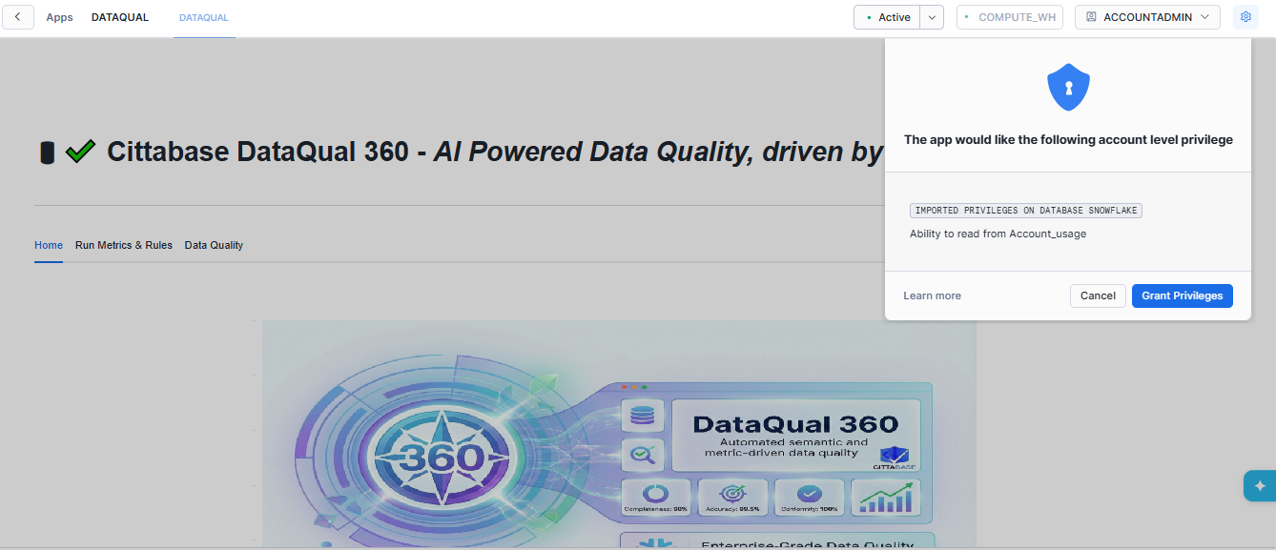

Initial Setup:
For better understanding of how the application works, a dataset has been provided along this documentation. It contains the SALES and EMPLOYEE tables for which the end-to-end Data Quality functionality will be demonstrated as follows.
If you would like to skip this example and choose any of your database, you could replace SALES database in the subsequent steps with <YOUR DATABASE NAME> and use tables, and the respective semantic view of your choice. Please note that respective GRANTS need to be executed as mentioned in the Step 5.

Step 1: Create and Use DATABASE
Create Database SALES;
Step 2: Use Schema
Use Schema PUBLIC;
Step 3: Load Tables using the provided files
Through the Snowsight interface, upload the provided SALES.csv and Employee.csv files and create EMPLOYEE and SALES table in the path SALES.PUBLIC.
Step 4. Create Semantic VIEW
Create Semantic View for the SALES and EMPLOYEE table using the provided SEMANTIC_VIEW.sql script.
Step 5: Execute the following Grants to the APP
GRANT USAGE ON DATABASE SALES TO APPLICATION DATAQUAL;
GRANT USAGE, CREATE TABLE ON SCHEMA SALES.PUBLIC TO APPLICATION DATAQUAL.
GRANT SELECT ON ALL SEMANTIC VIEWS IN SCHEMA SALES.PUBLIC TO APPLICATION DATAQUAL.
GRANT REFERENCES ON ALL SEMANTIC VIEWS IN SCHEMA SALES.PUBLIC TO APPLICATION DATAQUAL.
GRANT DATABASE ROLE SNOWFLAKE.CORTEX_USER TO APPLICATION DATAQUAL.
GRANT SELECT, INSERT, TRUNCATE, UPDATE, DELETE ON ALL TABLES IN SCHEMA SALES.PUBLIC TO APPLICATION DATAQUAL;
GRANT SELECT, INSERT, TRUNCATE, UPDATE, DELETE ON FUTURE TABLES IN SCHEMA SALES.PUBLIC TO ROLE ACCOUNTADMIN;
Step 6: Navigate to the Snowflake Native App
After importing the application from the Marketplace, open the Snowflake Native App.
You will see three main tabs: Home, Run Metrics & Rules, and Data Quality.
Navigate to the Run Metrics & Rules tab.
From here:
- Select the SALES database.
- Choose the PUBLIC schema.
- Pick the appropriate SEMANTIC_VIEW.
- Select the target table (e.g., SALES or EMPLOYEE) from the semantic view.
Once your selections are made:
- Click Generate Rules to automatically create semantic data quality rules based on the selected semantic view.
These generated rules are stored in SALES.PUBLIC.DQ_SEMANTIC_RULES.
- Next, click Run Validations to execute the data quality checks on the selected table (SALES/EMPLOYEE).
The validation results are stored in SALES.PUBLIC.DQ_REPORT.
Important:
Semantic rules are generated by utilizing the metadata defined in the semantic view.
To ensure accurate and high-quality DQ rule generation:
- Provide clear, meaningful, and detailed semantic descriptions for every column. The richer the description (e.g., expected format, business meaning, valid ranges, constraints), the more precise and effective the generated rules will be.
- Columns with weak, generic, or missing descriptions may lead to incomplete, inconsistent, or missing rules during generation.
- For the generated rules to be robust, ensure the semantic description clearly defines the column’s purpose, allowed values, business logic, or constraints.
Example:
For a column like CURRENCY, you could define semantic description like:
“Specifies the currency in which the sale was made. Allowed values: AUD, EUR, GBP, INR, JPY, CAD, USD.”
A strong description like this helps the system generate the correct validity rules based on allowed values.

Navigating the Streamlit Application:

- Run Metrics and Rules

This screen lets you select a database, schema, and semantic view using the drop down list to preview and explore the available data. Choose the respective Semantic view to proceed. You could also ask questions about the data related to the semantic view using the chat interface, for deeper insights.

Click on the “Chat” button to get a dedicated assistant toy answer your question about the data. For example, you could ask, “Which Market area had the highest sales ?”
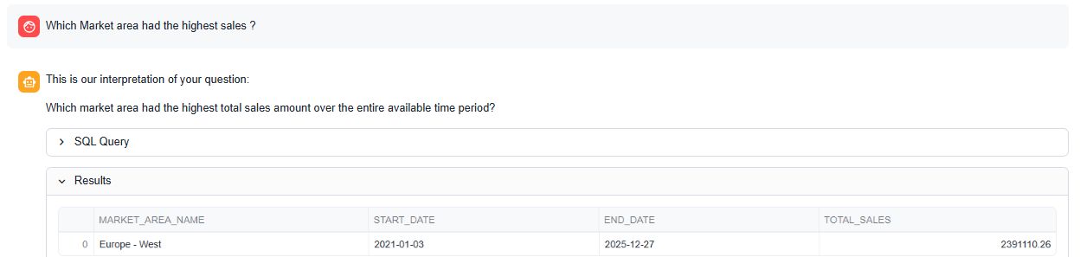

Next, view the table details by choosing the desired table in the dropdown menu.
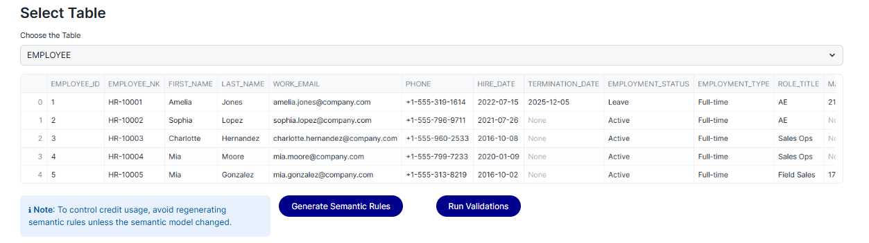

  - Generate semantic Rules: This button validates the descriptions of each field as specified in the semantic view and generates a set of relevant rules classified as one among - Completeness, Consistency, Timeliness, Uniqueness ,Validity and accordingly creates the respective table (DQ_GENERATED_RULES).
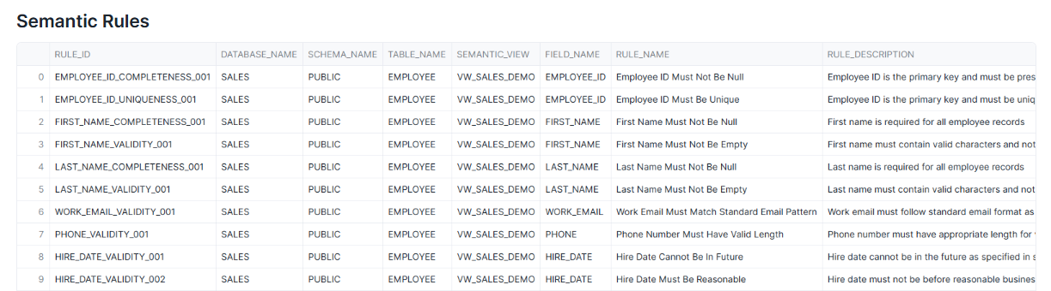
All rows will by default have an active flag value of ‘Y. You could choose to deactivate any rule, if it is not required for validation.
Note: To control credit usage, avoid regenerating semantic rules unless the semantic view has changed. If only the data has changed, semantic rules need not be re-generated. The Validations can be run directly in such cases (Step 1.2) to recalculate data quality on the latest data.
  - Run Validations:
This validates the data against the generated rules and populates a table with the final Data Quality results (DQ_REPORTS)

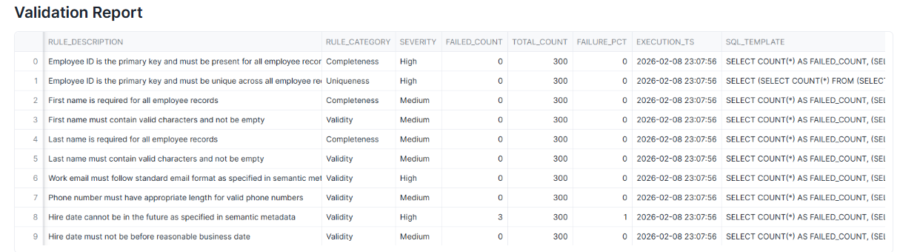

Both the DQ_GENERATED_RULES and the DQ_REPORTS table delete and re-populate rows for the respective tables, when they are re-run.
For example, if the SALES table’s semantic rule generation or validations are re-run, the SALES entries are deleted from the tables and re-populated.
Data Quality - Visualization:
Note: Please navigate to this tab only after rule generation and execution are complete for the chosen table.
This dashboard presents Exploratory Data Analysis (EDA) views for the selected database and table. Use the filters to choose the dataset and rule type, and explore data patterns, distributions, and quality insights.

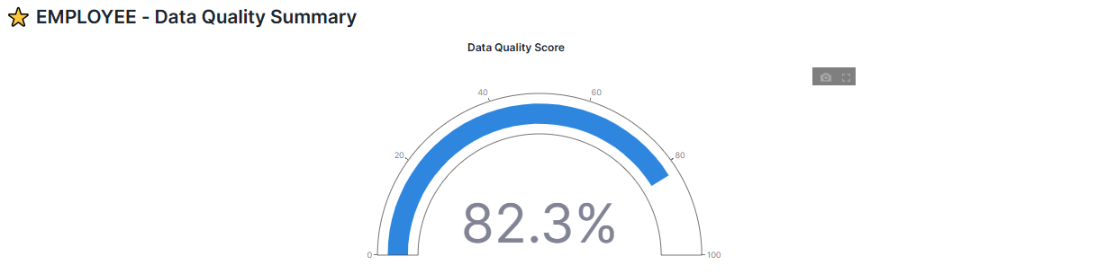
This section provides a high-level data quality summary for the selected table, highlighting the overall Data Quality Score for a selected table which is calculated using the below formula,
DQ Score of a table = (Failure count of columns / Total records in the table) * 100

The above cards provide a comprehensive overview of data quality performance. They highlight the total number of rules applied across the selected table, break down rules by category (such as Completeness, Validity, Uniqueness, Consistency, and Timeliness), display the average rule failure percentage, and show the latest execution timestamp. Together, they offer a quick yet detailed snapshot of the table’s overall data quality health and recent monitoring activity.

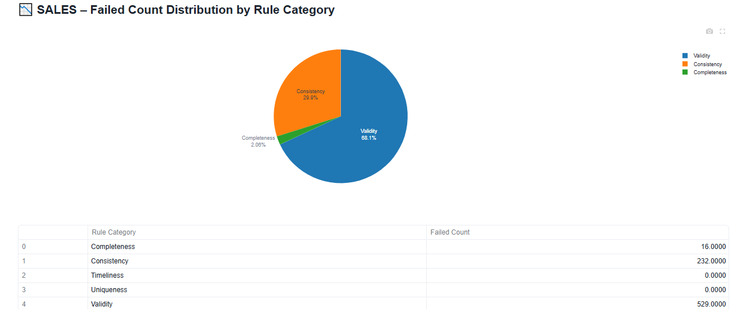

This view shows the distribution of failed records across major data quality rule categories, helping you pinpoint which dimensions contribute most to data quality issues. These categories include:
- Completeness - checks whether required fields contain missing or null values.
- Validity - ensures values follow expected formats, ranges, data types, or business rules.
- Uniqueness - identifies duplicate records or fields that should be unique but are repeated.
- Consistency- verifies whether data is aligned across related fields, references, or lookup rules.
- Timeliness - checks whether dates or timestamps fall within acceptable time ranges and are not outdated or future-dated.
By visualizing failures across these dimensions, this view helps quickly highlight where data issues are most concentrated and which aspects need attention.

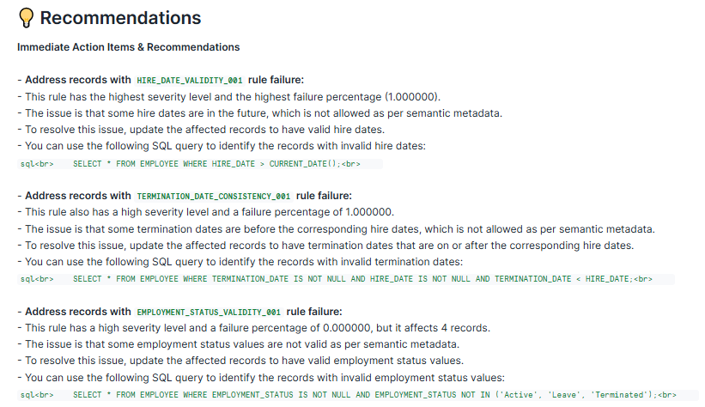

This section provides clear, LLM-driven recommendations to help teams quickly diagnose and resolve data quality issues. It highlights high-severity rule failures, explains their probable root causes based on semantic understanding, and outlines the potential business impact. For each issue, the system generates targeted SQL queries to identify affected records and guide troubleshooting. It also suggests practical fixes such as correcting invalid values, updating reference mappings, or reprocessing specific data segments to restore data accuracy. These actionable insights enable faster remediation, reduce manual investigation, and improve the overall reliability and trustworthiness of the data ecosystem.

Note:
DataQual 360 utilizes the claude-opus-4-5 (for rule generation based on semantic view) and claude-4-sonnet LLM within Snowflake. Please review credit usage. Note that credits will be charged for LLM usage as outlined in the credit consumption table -https://www.snowflake.com/legal-files/CreditConsumptionTable.pdf

